**Task for today: Jenkins Installation complete Name: Mohd Ehtesham Date: August 30, 2024**

1. Setup jenkins CICD pipeline using freestyle job using below code. [https://github.com/betawins/hiring-app.git](https://github.com/betawins/hiring-app.git" \t "https://app.slack.com/client/T03TRQ064Q0/_blank)

Stages: 1) Git Clone

1. Sonarqube Integration
2. Maven Compilation
3. Nexus Artifactory
4. Slack Notification
5. Deploy On tomcat
6. Git Clone

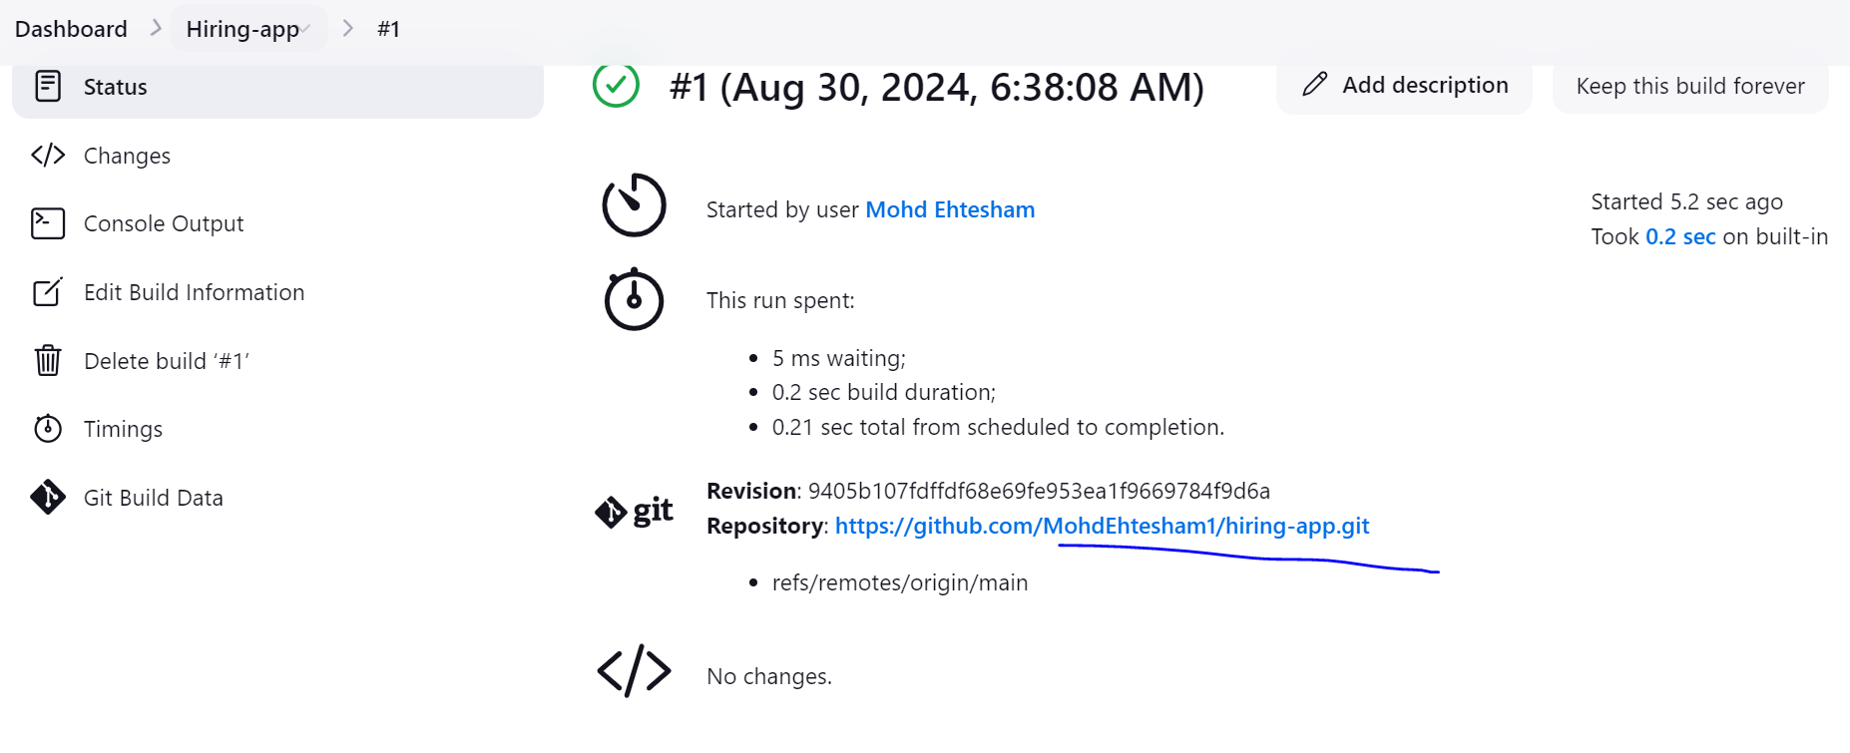

1. Sonarqube Integration

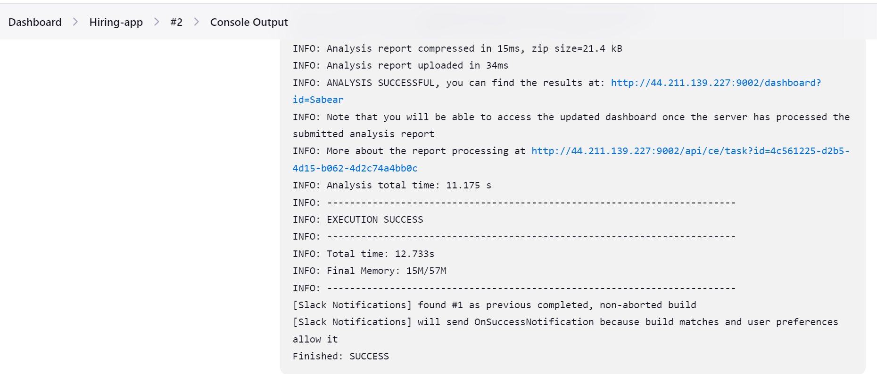

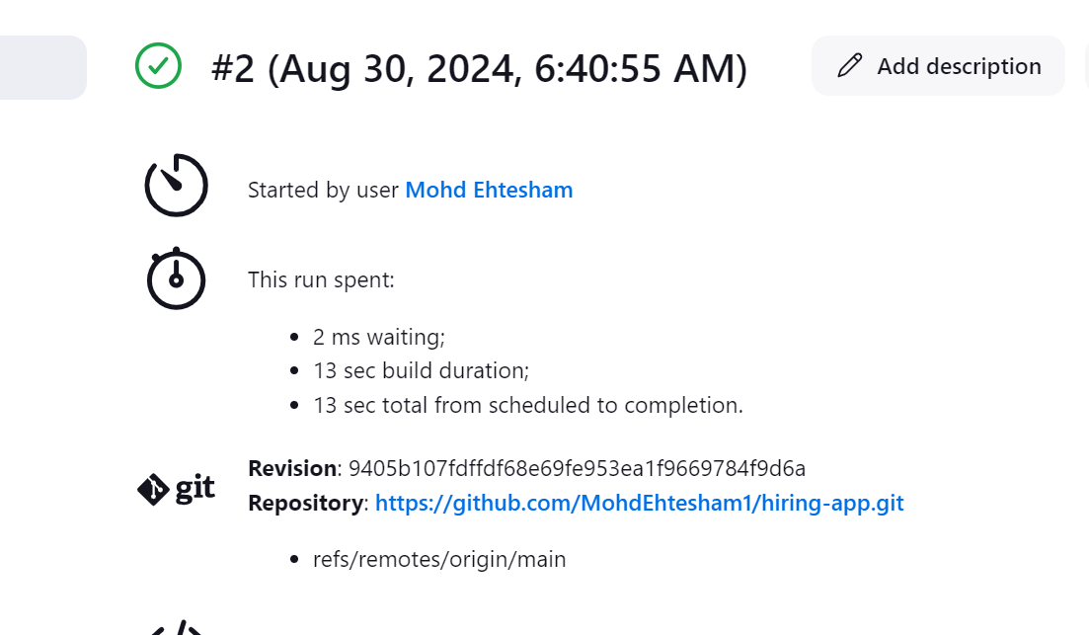

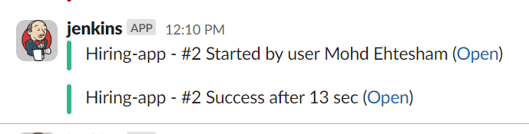

1. Maven Compilation

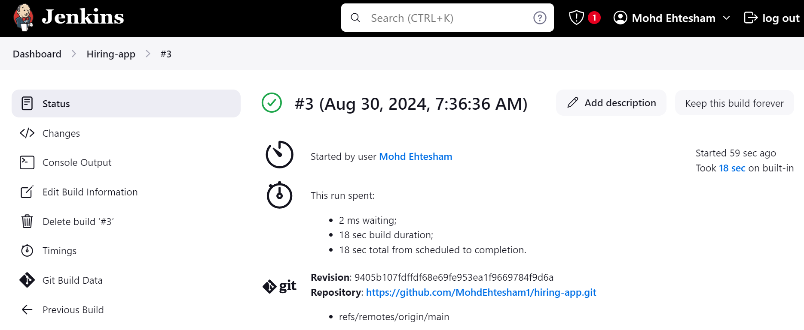

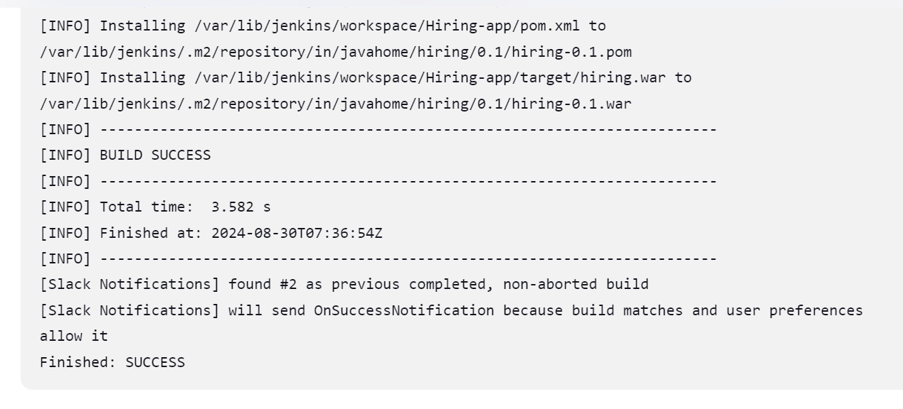

1. Setup jenkins job using freestyle job using below code. [https://github.com/betawins/Techie_horizon_Login_app.git](https://github.com/betawins/Techie_horizon_Login_app.git" \t "https://app.slack.com/client/T03TRQ064Q0/_blank)

Stages: 1) Git Clone

2)Sonarqube Integration

1. Maven Compilation
2. Nexus Artifactory
3. Slack Notification
4. Deploy On tomcat

Git Clone

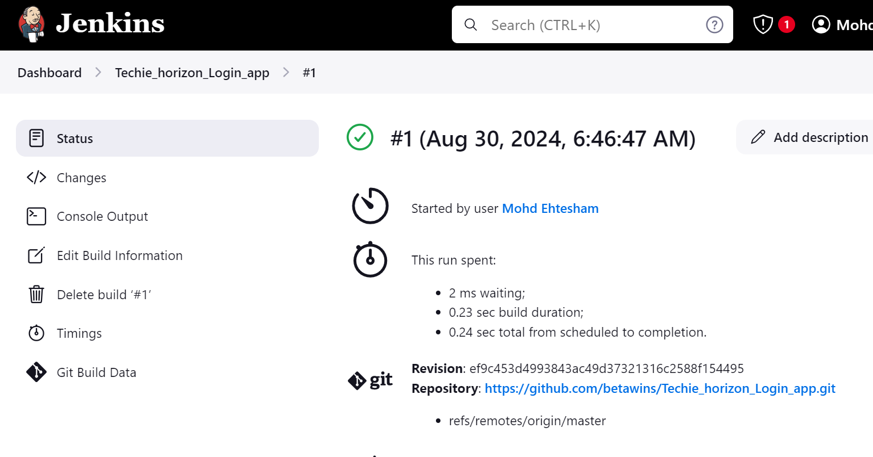

Sonarqube Integration

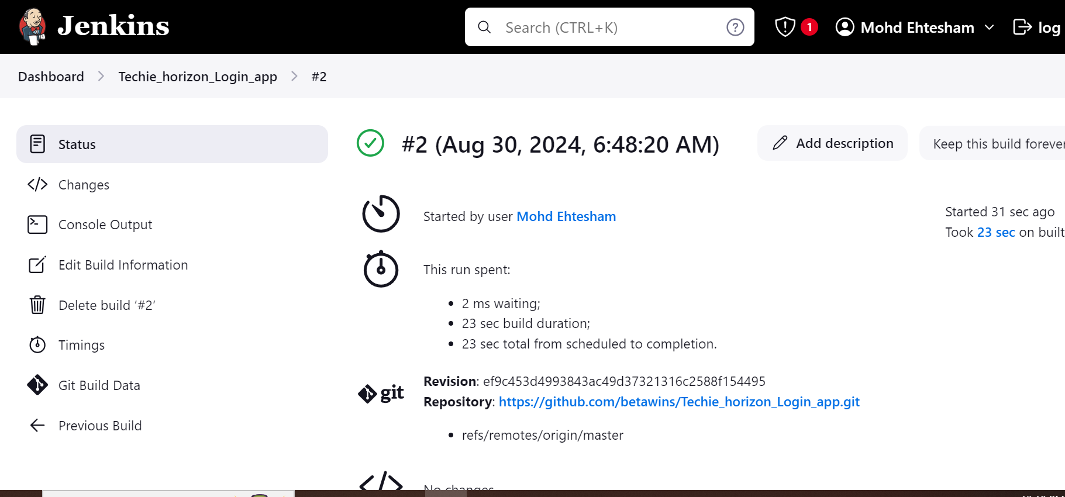

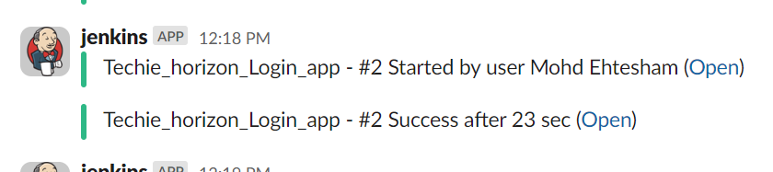

Maven Compilation

